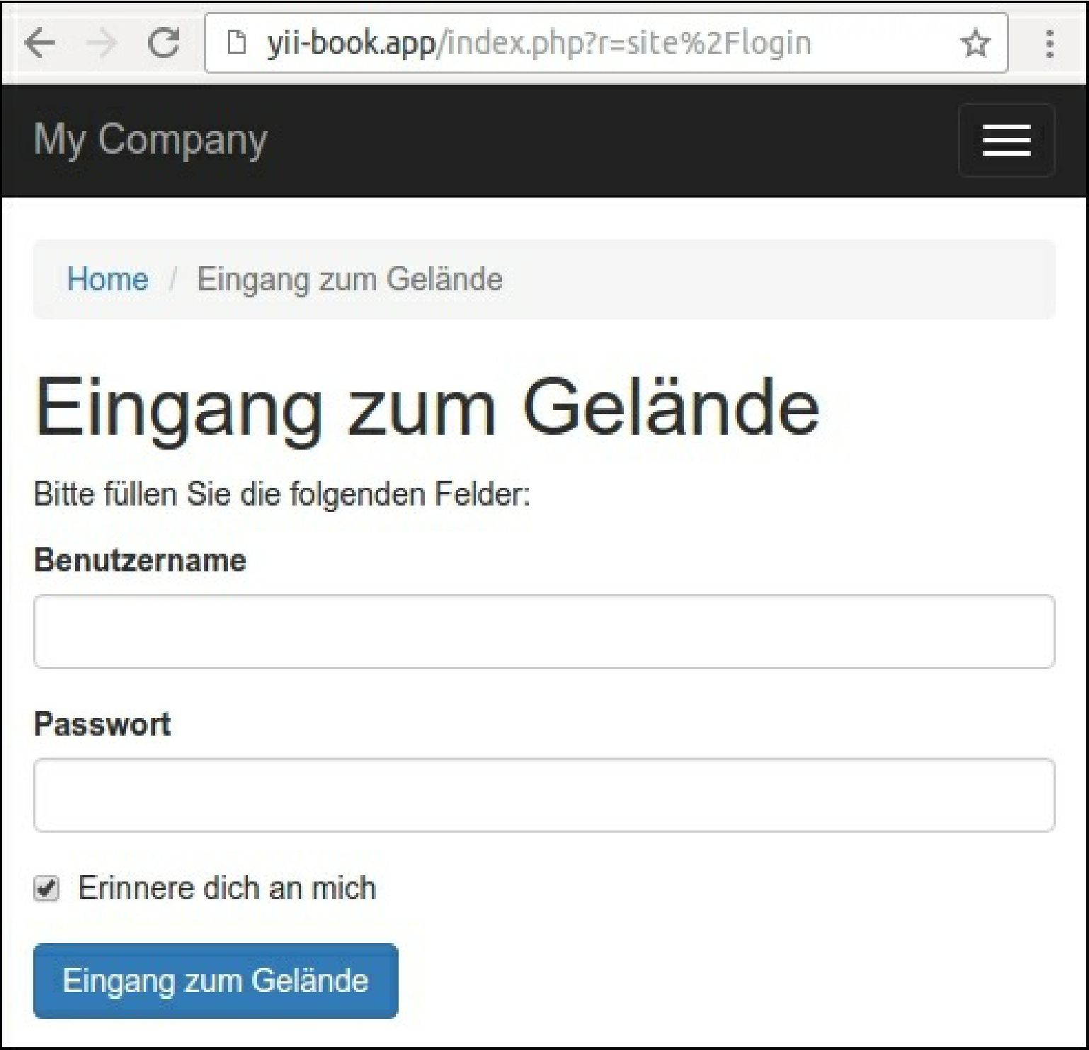

16. The built-in frameworks messages and default validation errors will be translated automatically.

How it works...

Yii2 provides the Yii ::t() method for translating interface messages via the ii8n component, which supports different types of sources. In this recipe, we use yii\ii8n\hpMessageSource, which stores translated messages in plain PHP files.

The framework does not have artificial intelligence and does not translate messages by itself. You must put prepared translations in files or in the database and framework to get the needed message from this message source.

You can set the current language manually: $config = [

'id' => ' basic',